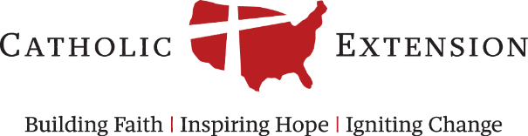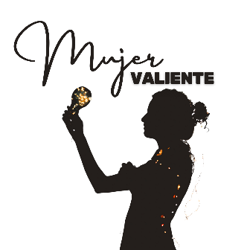

Mujer Valiente 2024
Individual Leader Participant Profile
Individual leader participant information to be collected by Diocesan Hispanic Ministry Directors for the group application. A complete list of participants and individual profiles must be submitted to the Diocesan primary contact, who will need to add these fields for each one.
Diocesan Hispanic Ministry Directors: Participants must be invited female leaders who are active in an extension diocese, at the parish or diocesan level. The main criterion for selecting participants is their love of the Catholic faith, their desire to deepen it, and their commitment to sharing it with others. Please send a complete list of participants and individual profiles to your Diocesan primary contact for application submission.

Invited participants: Please provide a brief bio about yourself in a few sentences, and answer the questions below:

Short biography:

1. Name:

2. Parish:

3. Ministry:

4. Diocese:

5. Email:

6. Telephone:

7. What is your preferred language for conference sessions?
English Spanish

8. MINISTRY: What ministry programs are you in currently, or have been, involved in and at which level?

9. PARISH: Name of parish/number of families/parishioners that it serves? Primary ethnic group served, if applicable.

10. GOAL(S): What are their long-term service goals in their parish/diocese and the Church overall?

