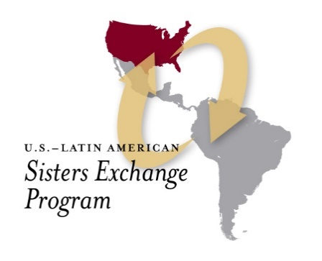

**Latin American Sisters academic scholarship**

**St. Mary's University of Minnesota**

Catholic Extension is pleased to offer the opportunity for Hispanic women religious to participate in a Masters Degree program beginning in Fall 2022. This scholarship covers tuition to attend courses online and in person through a partnership with St. Mary's University of Minnesota. Sisters who apply and qualify will earn a master's degree in Integrated Studies with a concentration in Human Services and Pastoral Care. Courses are offered in Spanish.

**Timeline:**

This program will end in 2024/2025, with the expectation that:

• Sisters will participate in at least two required academic Catholic Extension meetings each year that focus on academics or continuing education and other trainings.

• To the best of their abilities, the sisters will complete the three-year program and report each year on the academic benefits they have received.

**Funding:**

This full academic scholarship will cover the following:

• Up to $ 40,000 each year for three years to cover tuition, other expenses and educational travel (including: cost of flight, food, lodging)

• Counseling and spiritual and academic accompaniment

* up to $4000 stipend is awarded to the sister for a ministry Project during the three year program, to be determined at a later date, related to human development.
  + any support to families in need must be recorded and data must be collected to demonstrate at least 400 people reached

**Commitment of the diocese:**

Participating dioceses must understand that:

• Sisters will earn a master's degree from St. Mary’s University of Minnesota with the help of other Catholic Extension partner universities.

• Because the academic workload is heavy, it is important that sisters have the time they need to attend courses online and in person or complete assignments.

**Deadline to submit scholarship inquiries online with Catholic Extension:** April 2022