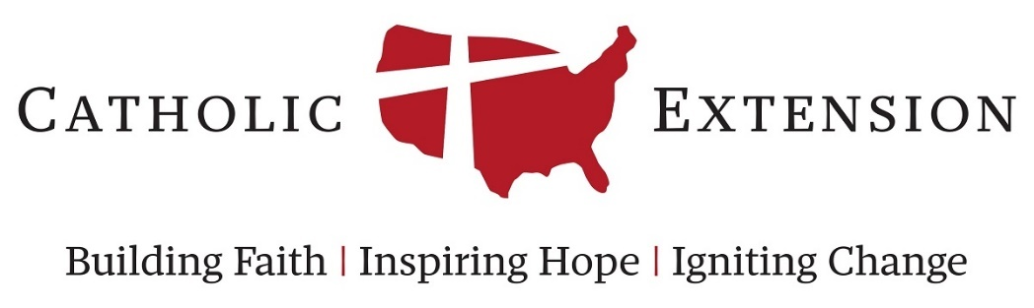

Draft Application Form for Grant Category:
Building Leaders (Non-Seminarian Education)

This document is an example of the questions that are presented on the Catholic Extension grants form for the category of Building Leaders (Non-Seminarian Education).

This is provided as a sample and to assist diocesan contacts in collecting the information needed from others throughout the diocese. This document can be shared with onsite contacts to assist in compiling responses in preparation of an official funding request to Catholic Extension.

Please note that all funding requests must still be officially submitted online through our grant application login linked at https://www.catholicextension.org/grant-information/

Applications will not be accepted by sending this form to Catholic Extension, or as an attachment to an online application. All information must be filled in the appropriate field in the official online grant application. If you have further questions, please contact our staff at mission@catholicextension.org

Organization and Contact Information

Organization Name:
Street Address:
City, State, Zip:
Phone:
Website Address:

Primary Contact Information

Diocesan Staff Contact:
Diocesan Contact Job Title:
Street Address:
City, State, Zip:
Diocesan Contact E-mail:
Office Phone:

Onsite Contact

Onsite Contact Name:
Onsite Contact Job Title:
Street Address:
City, State, Zip:
Onsite Contact E-mail:
Office Phone:

Please list the Bishop or Administrator of the Extension Diocese who has given endorsement

Bishop Name:
Bishop Title:
Street Address:
City, State, Zip:

Basic Request Information

Name of education program: (10 words or less):

Total Grant Amount Requested:

Multi-Year Grant Requests Only:
If this is a request for multi-year funding, please check this box and complete the following year by year funding fields. Otherwise, please skip this box.

Year 1 Grant Amount:
Year 2 Grant Amount:
Year 3 Grant Amount:

Please describe the nature of this training or formation and the benefits which the ministers will derive from it. Explain where you see a connection to our Grant Guidelines (400 words or less):

If this grant were to be summarized into a 1-2 sentence description for a donor, what would that be? (100 words or less. Please be clear about how the grant funding will be used and the impact it can provide.):

People Served and Need

Please enter the total number of students that this grant would fund during the coming year (If request is for deacon formation funding, please count each couple as one person):

Please list the students who will benefit including name, institution attended, course of studies, year of certification/ordination/graduation, student age or ethnic background (or attach as a separate document at the end of this application) (250 words or less):

Has this type of education program or opportunity ever been provided in the past for this group of people? If so, when did this opportunity occur? (100 words or less)

What are the immediate and long term benefits of this education program? (i.e. organizational, intellectual, etc.) Describe below or attach on a separate document (500 words or less):
Why at this particular moment is there a financial need for this grant from Catholic Extension? Please be specific (100 words or less):

Catholic Extension Grant Plans

Has this program or fund ever received funding from Catholic Extension for a similar purpose? If so, please explain (150 words or less. This can help us tell a narrative about our history with this parish or ministry)

Previous Grant Amount (If known, or otherwise leave blank):
Approximate Previous Grant Date (If known, or otherwise leave blank):

If approved, please specify an appropriate time frame for payment of this grant. Why is this time frame favorable to your financial needs? (100 words or less)

Will there be ongoing costs for this education program in subsequent years? (Yes/No)

Describe the steps that have been or will be taken to secure funding toward long-term sustainable support of this institution or program in the future. Please be specific. Priority consideration will be given to requests that provide solid plans for progress toward long-term self sustainability. (200 words or less)

Sources of Revenue and Expenses

Please list the other major sponsor(s) of this program or project and the amount of funds that they will supply.

Source Name 1
Source Amount 1

Source Name 2
Source Amount 2

Source Name 3
Source Amount 3

What are the total expenses for this program/project during the proposed grant year?

Please list the expense(s) to which the proposed grant funds will apply during the grant year:

Expense Name
Expense Amount

Expense Name
Expense Amount

Expense Name
Expense Amount

Expense Name
Expense Amount

Expense Name
Expense Amount

Please list your previous total revenue as indicated below, if applicable.

2 years ago
1 year ago
Current year

Please list your previous total expenses as indicated below, if applicable.
2 years ago
1 year ago
Current year

Please explain significant revenue and/or expense variations, if any.

Reporting Requirements

What is the proposed education/academic start date for the year of the grant?

How long is the program (or academic year)?

Please list all significant dates that pertain to the students or program during this grant year of which Catholic Extension should aware. (i.e. quarterly, mid-term, graduation, etc.)

All grants funded will be expected to provide a report at the end of their grant timeline. This will include asking the recipient to report back on the goals and measurements entered below, and reflecting on the impact these measurable achievements had on the program's overall mission.

Please outline the goals for the year of the grant (250 words or less)

What data will you track to measure the success of this educational program?

Some examples of metrics to track:
- Number of people served
- Hours of service or formation provided
- Number or frequency of activities/events held
- Increase in revenues, attendance, or budget goals
- Etc.

Attachments

To complete this online application, please provide additional documentation by uploading your electronic files as separate attachments (when necessary, as required by the guidelines). The descriptions of the documents which correspond to the attachment headings are as follows:

For initial or ongoing student education (deacon, professional religious, or lay leader funding):

- Endorsement Letter (Required) : Letter of endorsement from diocesan bishop (one letter is sufficient for simultaneously submitted applications).
- Program Budget (Required): Budget for the year of the grant.
- Student Information: A list of students who will benefit from this program including name, institution attended, course of studies, year of certification/ordination/graduation, student age, and ethnic background.
- Other Attachment: Any other document which you believe would be important or helpful to our decision.

For initial or ongoing student education: volunteer and professional pastoral formation:

- Endorsement Letter: Letter of endorsement from diocesan bishop (one letter is sufficient for simultaneously submitted applications).
- Program Budget: Budget for the year of the grant.
- Personal Statement: Statement from student, one page or less, regarding their motives for applying and intentions for ministry, if applicable.
- Acceptance Verification: Verification of lay students'/attendees' acceptance or enrollment to program, if applicable.
- Recommendation Letter: From a pastoral leader, either lay or ordained, who knows the applicant personally or professionally, if applicable.
- Student Information: A list of students who will benefit from this program including name, institution attended, course of studies, year of certification/ordination/graduation, student age, and ethnic background.
- Other Attachment: Any other document which the grantee believes to be help to our decision.

