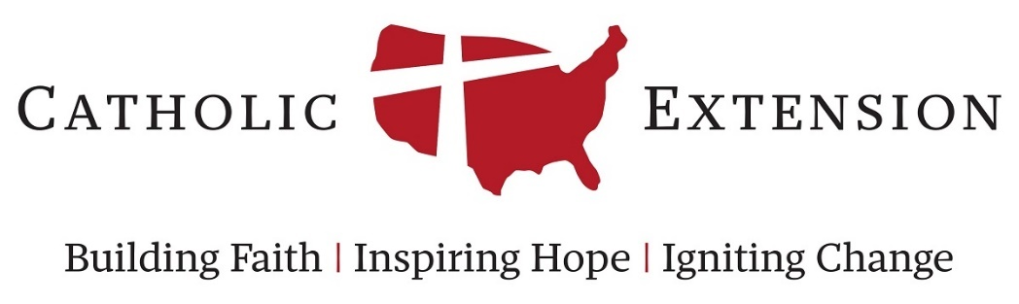

Draft Application Form for Grant Category:
Building Churches and other Facilities

This document is an example of the questions that are presented on the Catholic Extension grants form for the category of Building Churches and other Facilities.

This is provided as a sample and to assist diocesan contacts in collecting the information needed from others throughout the diocese. This document can be shared with onsite contacts to assist in compiling responses in preparation of an official funding request to Catholic Extension.

Please note that all funding requests must still be officially submitted online through our grant application login linked at https://www.catholicextension.org/grant-information/

Applications will not be accepted by sending this form to Catholic Extension, or as an attachment to an online application. All information must be filled in the appropriate field in the official online grant application. If you have further questions, please contact our staff at mission@catholicextension.org

Organization and Contact Information

Organization Name:
Street Address:
City, State, Zip:
Phone:
Website Address:

Organizational Background: (Information about the specific organization requesting funding (not the entire diocese) such as mission, history, etc.):

Weekly Collection (If grantee is a parish or minister working at a parish, what is the weekly collection?):

Parish/Mission Annual Operation Budget (If the grantee is a parish or mission, please enter their annual operating budget here):

Primary Contact Information

Diocesan Staff Contact:
Diocesan Contact Job Title:
Street Address:
City, State, Zip:
Diocesan Contact E-mail:
Office Phone:

Onsite Contact
Such as Pastor or Onsite Project/Program Manager

Onsite Contact Name:
Onsite Contact Job Title:
Street Address:
City, State, Zip:
Onsite Contact E-mail:
Office Phone:

Please list the Bishop or Administrator of the Extension Diocese who has given endorsement

Bishop Name:
Bishop Title:
Street Address:
City, State, Zip:

Basic Request Information

Title of Program or Project (10 words or less):

Grant Amount Requested:

Please briefly describe the reason and purpose of the project and the work to be done. If work is to be done in phases, please describe each step. (750 words or less. Facilities projects with Catholic Extension, whether new construction, expansion, or facility repair/renovation are required to be done as a matching fundraising challenge to bring the project to completion. )

If this grant were to be summarized into a 1-2 sentence description for a donor, what would that be? (100 words or less. Please be clear about how the grant funding will be used and the impact it can provide.):

People Served and Need

Primary ethnic group funding proposes to serve
While we understand that many parishes and ministries are multicultural, it is helpful to know the primary group that will be assisted by this funding. If there are multiple that could be selected, please note this in the main grant description on the "Basic Request Information" tab.

Please enter the total number of families that this program/project ministry proposes to directly serve during the year of the grant. (Number of families cannot be larger than the number of people entered below):

Please enter the total number of people that this parish or ministry proposes to directly serve during the year of the grant.

Please describe any other demographic characteristics of the people that this facility will serve, which you feel are pertinent. (i.e. age group, gender, urban/rural, etc.) (100 words or less)

Why at this particular moment is there a financial need for this grant? (100 words or less)

If approved, please specify an appropriate time frame for payment of this grant. Why is this time frame favorable to your financial needs? (100 words or less)

Describe the rationale for the design and size of the new facility (250 words or less):

Where is the nearest parish or comparable facility? Please explain (100 words or less):

How many miles away is the nearest church or comparable service provider?

Catholic Extension Grant History

Has this particular ministry or organization ever received funding from Catholic Extension? If so, please explain. (150 words or less. This can help us tell a narrative about our history with this parish or ministry.)

Previous Grant Amount (If known, or otherwise leave blank):
Approximate Previous Grant Date (If known, or otherwise leave blank):

If you are from a parish, do you currently purchase or have a sponsor purchase calendars for you?

If yes, who is your calendar vendor?
This answer does not have any impact on our funding decision, but is only for information-collecting purposes

Project Expenses

In this section, please provides details on the expenses of the proposed project.

A complete breakdown of the total expenses will need to be added as an attachment at the end of the application.

Please provide the project expense information for which the proposed grant funds will apply.

Expense Name 1:
Expense Amount 1:

Expense Name 2:
Expense Amount 2:

Expense Name 3:
Expense Amount 3:

Expense Name 4:
Expense Amount 4:

Expense Name 5:
Expense Amount 5:

Expense Name 6:
Expense Amount 6:

Expense Name 7:
Expense Amount 7:

Expense Name 8:
Expense Amount 8:

Expense Name 9:
Expense Amount 9:

Expense Name 10:
Expense Amount 10:

What is the total budget for this project?

Please detail the loans that will be or have been made in order to help complete the construction of this project. Please name the lender, the amount of the loan, and the interest rate on the loan.

Lender Name:
Loan Amount:
Loan Interest Rate:

Lender Name:
Loan Amount:
Loan Interest Rate:

Lender Name:
Loan Amount:
Loan Interest Rate:

Please estimate the ongoing costs for the next three years or attach in the business plan at the end of this application.

Fundraising Activity

In this section, please provide information about funding you have already raised, secured and plan to raise for this project. Please list all of the presently accumulated funds for this project.

These are funds that are already in your possession or funds that have already been spent on needs for the proposed project. This may include pledge payments already made, savings for building project needs, or anything else already in hand.

Source Name 1:
Source Amount 1:

Source Name 2:
Source Amount 2:

Source Name 3:
Source Amount 3:

Please list all major sources of promised or pledged funds for this project.

These are funds that have been pledged to the project but have yet to be collected. This may collect donor pledges yet to be paid (can be listed as a sum total), diocese commitments, or anything else not yet in hand but pledged or expected.

Pledge Name 1:
Pledge Amount 1:

Pledge Name 2:
Pledge Amount 2:

Other avenues of funding that may be needed in order to fund the project to its completion. Anything else not listed above, but needed in addition to anything listed above and a potential Catholic Extension grant.

Proposed Source:
Proposed Amount:

If there are not enough fields to detail all pledged and proposed sources of funding, please include this complete information as an attachment to this request on the last page.

Reporting Requirements

What is the anticipated or actual start date for this project?

What is the estimated duration of this project?

If your project has begun, what percentage has been completed to date? If you have not yet begun, list all the contingent factors impacting the start date. (200 words or less)

All grants funded will be expected to provide a report at the end of their grant timeline. This will include asking the recipient to report back on the goals and measurements entered below, and reflecting on the impact these measurable achievements had on the program's overall mission.

Please outline the goals for the year of the project. (250 words or less)

What data will you track to measure the impact of this program/project? (250 words or less)

Some examples of metrics to track:
- Number of people served
- Increased mass attendance or program participation
- Number or frequency of activities/events held
- Increase in revenues, attendance, or budget goals
- Etc.

Attachments

To complete this online application, please provide additional documentation by uploading your electronic files as separate attachments (when necessary, as required by the guidelines). The descriptions of the documents which correspond to the attachment headings are as follows:

Required Documents
- Endorsement Letter: Letter of endorsement from diocesan bishop (one letter is sufficient for simultaneously submitted applications)
- Project Budget/Costs: Delineation of repair or equipment cost estimates, relevant documentation to support such estimates. This document should come from the hired or proposed contractor for the project.
- Photographs: Photographs of current church, damage that needs repair, or any and all other photos to help show the need present in this project request. All photos must be attached as .jpg, .jpeg, .png, .bmp, .gif, or other acceptable photo file format. As often as possible, we would like receive before/after versions of the same photograph (after photographs would be submitted following project completion as a part of the final report) to help our donors be able to see the difference and impact of their funding.

Other Recommended Documents
- Funding Plan: A summary of fundraising activity to date and fundraising in the future, to add up to the total project cost
- Drawings or Sketches: Of the current structure, proposed end product, or planned new facility
- Other Attachment: Any other document which the grantee believes to be help to our decision

